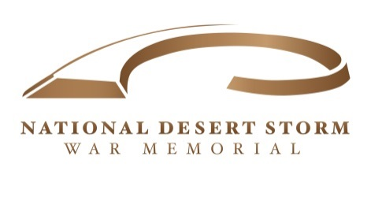

Post Office Box 29091 George H W Bush
Washington DC 20017 President, USA
Honorary Chairman

National Desert Storm War Memorial Background Information and Details for Letter Writing Campaign

* December 2010- Effort to create the memorial was initiated (Just Prior to the 20th Anniversary
Reunion in College Station Texas/Bush Library)

* Congressman Dr. Phil Roe (TN-01) current Veterans Affairs Committee Chairman introduces the
Enabling legislation in the House of Representatives.

* Senators Boozman (AR) and Donnelly (IN) introduce companion legislation in the U.S. Senate

* On May 28^{th,} 2014 HR 503 passes in the US House of Representative by a vote of 370-0

* On December 19th of 2014 S.995 is signed into law by President Obama as part of the NDAA. The
Memorial effort is now authorized to be built on federal land in Washington, through 100% private
funding.

* The process of site selection is initiated with the NDSWM Association working in conjunction with
the National Park Service and the NDSWM Design Committee. The process begins with a possible
100 locations, is quickly pared down to 30 possibilities. Those 30 possibilities are then further
Winnowed down to the final TOP TWO possible locations. One site is adjacent to the Memorial
Traffic Circle on the Arlington side of the Potomac. The second and preferred site is at 23rd and
Constitution directly across from the US Institute of Peace and near the Lincoln Memorial and
Vietnam Memorial. A highly visible and pedestrian friendly location accessible to millions of
Visitors.

* On January 28^{th,} 2016 NCMAC recommends the National Desert Storm War Memorial be in a
Prominent Area I Location. The letter of recommendation is then sent to the Department of the Interior
3 months later. After 6 months, a letter concurring with the NCMAC recommendation for an Area I
Location is sent from the Secretary of the Interior to the Speaker of the House and the President of the
Senate. On March 31st President Trump signs SJ RES 1 into law, authorizing the memorial to be built
In Area I.

* The next action is the final phase of the site selection process to determine which of the two locations
Will be the location for the memorial. The NCMAC Hearing takes place on 16 May at the National
Building Museum in Washington. The hearing will include testimony from Gold-Star Mother
Christine Jensen from Indianapolis, IN along with Ambassador Skip Gnehm, U.S. Ambassador to
Kuwait at the time of the Iraqi Invasion. There will also be a videotaped statement from Richard
Lowry, a world-renowned Desert Storm Expert Historian and Author. Mr. Lowry is unable to appear
in-person due to a terminal lung disease which has rendered him bedfast in a hospital. Letters of
support have been secured from Generals Boomer, Franks, and Admiral Stanley Arthur. Many other
letters of support for the 23rd and Constitution location are being obtained from Veterans of Desert
Storm, military organizations, concerned citizens, as well as members of President Bush’s Cabinet in
1990-91. We believe based on experience with the Area I designation process, that the letter
writing campaign will weigh significantly in the NCMAC Commission’s ultimate decision. Our goal
is to have 1,000 letters sent to NCMAC Chairman Peter May supporting the 23rd and Constitution
location and I am confident that we can make it happen.

* Based on communication with NCMAC and our team of experts (AECOM) we have been assured that
the location will be determined and set in stone NO later than late Summer.

* The goal for completion of the National Desert Storm War Memorial is by Veterans Day 2019
(11November).

