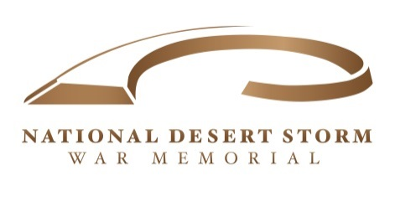

Post Office Box 29091 George H W Bush
Washington DC 20017 President, USA
Honorary Chairman

NCMAC Sample Letter

*Folks, I just wanted to put out several of the parameters for this letter. First, PLEASE use this as a template and DO NOT duplicate what I have written. This is intended to be a guideline which you can use for format purposes. These letters are much more effective if they are written in your OWN WORDS!

* Please address the letters to: Mr. Peter May, Chairman
NCMAC
1100 Ohio Drive S.W. Room 220
Washington, D.C. 20242

* Please send the letters as soon as possible. The due-date for receiving the letters is 3 May!

* Our sincere thanks for taking the time to write these letters! Last year the letter campaign was EXTREMELY successful and made THE DIFFERENCE with the Commission! Thanks for your help!!

* PLEASE feel free to stress the important aspects of Desert Storm such as: 1) Our Fallen 2) The 600,000-PLUS who served 3) The liberation of Kuwait 4) The 34-country coalition aspect
5) The memorial should be located CLOSE to the Vietnam Memorial because of our close ties to Vietnam, since ALL of our Senior Leadership were Vietnam Veterans and we also had many in the field who served previously in Vietnam…

SAMPLE LETTER:

Dear Mr. May,

I am writing you concerning the absolute necessity for the National Desert Storm War Memorial to be located on the available site at 23rd and Constitution Avenue in Washington, D.C. Operation Desert Storm was a major event in our country’s history and should be treated as such by placing in near the other “War Memorials” on the National Mall. Placing the memorial within walking distance to the other memorials will ensure that the millions of annual visitors to Washington will be able to pay tribute to the almost 400 brave Americans who made the supreme sacrifice.

Desert Storm accomplished many things including the liberation of Kuwait as well as changing the public’s perception and treatment of our military. Operation Desert Storm and all who served should be afforded the same honor and respect as all of the other wars past and present by allowing it to be located in the prominent and fitting location of 23rd and Constitution.

Respectfully,

John Doe

